Docker Images Project — KodeKloud
Step 1: Open the KodeKloud lab
- Log in to KodeKloud.
- Open the Docker Images lab.
- Start the lab and wait for the terminal to appear.
- You should see a prompt similar to:
root@docker-host ~ ➜
Step 2: List all Docker images
Run:
docker images
Purpose: Displays the Docker images available on the system.
Your screenshot shows images including:
- nginx:alpine
- nginx:latest
- postgres:latest
- redis:latest
- ubuntu:latest
- webapp-color:latest
- webapp-color:lite
Important columns:
Column | Meaning
IMAGE | Repository and tag
ID | Image identifier
DISK USAGE | Disk space used
CONTENT SIZE | Image content size
EXTRA | Additional image information
Step 3: Display only the webapp-color images
Run:
docker images webapp-color
Your output should list:
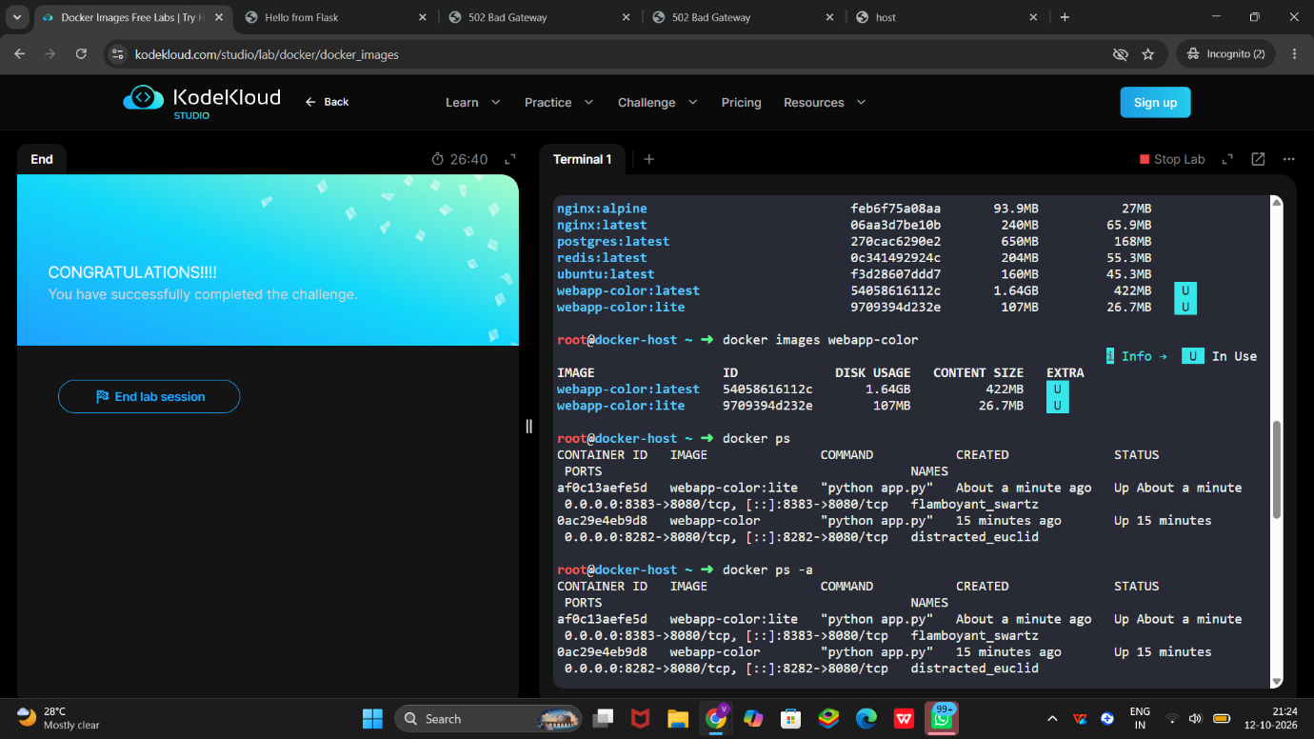
webapp-color:latest
webapp-color:lite
Explanation: The latest and lite tags identify two versions or variants of the webapp-color image.
Step 4: Check running containers
Run:
docker ps
Your screenshot shows two running containers with these port mappings:
Container image | Host port | Container port
webapp-color:latest | 8383 | 8080
webapp-color:lite | 8282 | 8080
Explanation: Both applications listen on port 8080 inside their containers, but Docker exposes them on different host ports.
Step 5: List all containers
Run:
docker ps -a
This lists all containers, including stopped or exited containers.
Your screenshot shows both application containers running.
Step 6: Understand how the containers are started
If you need to recreate this setup in a fresh lab, the example commands are:
docker run -d --name webapp-latest -p 8383:8080 webapp-color:latest
docker run -d --name webapp-lite -p 8282:8080 webapp-color:lite
What the options mean:
- docker run — creates and starts a container.
- -d — runs the container in the background.
- --name — gives the container a name.
- -p 8383:8080 — maps host port 8383 to container port 8080.
- webapp-color:latest — specifies the image and tag.
Important: Your existing containers are already running. Do not run these commands again in the current lab unless you need to recreate them; duplicate container names will cause errors.
Step 7: Open the first website
Use the KodeKloud preview link for port 8282.
Your screenshot shows the application page displaying a heading similar to:
Hello from 0ac29e4eb9d8!
This confirms the application is responding through that port.
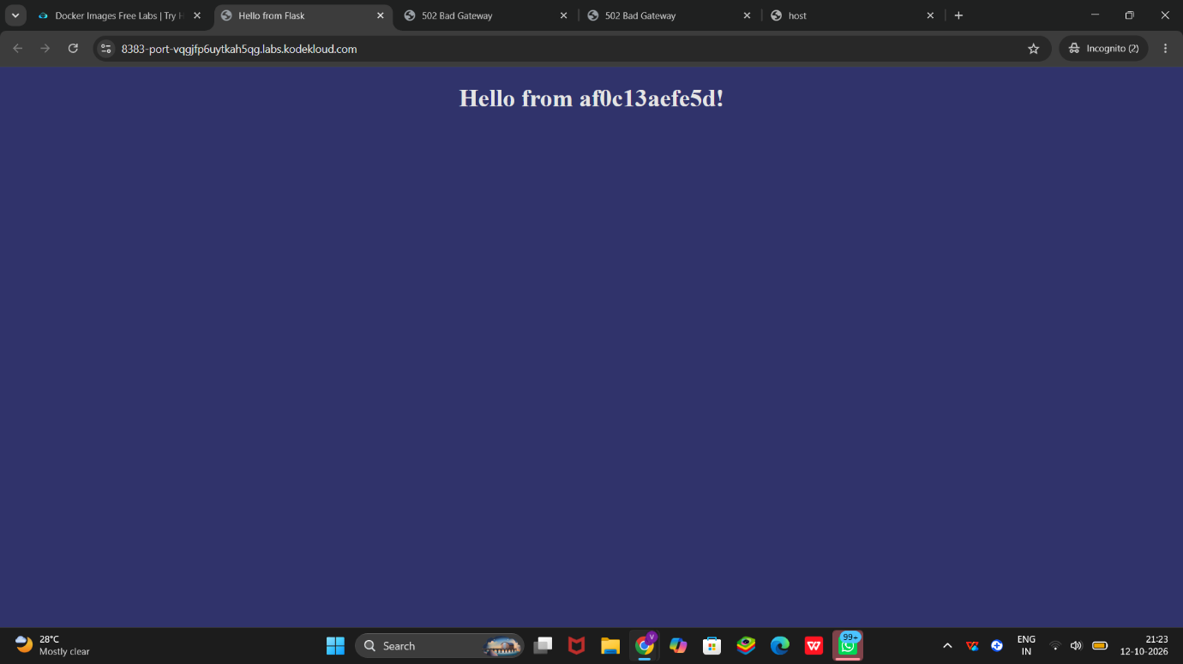
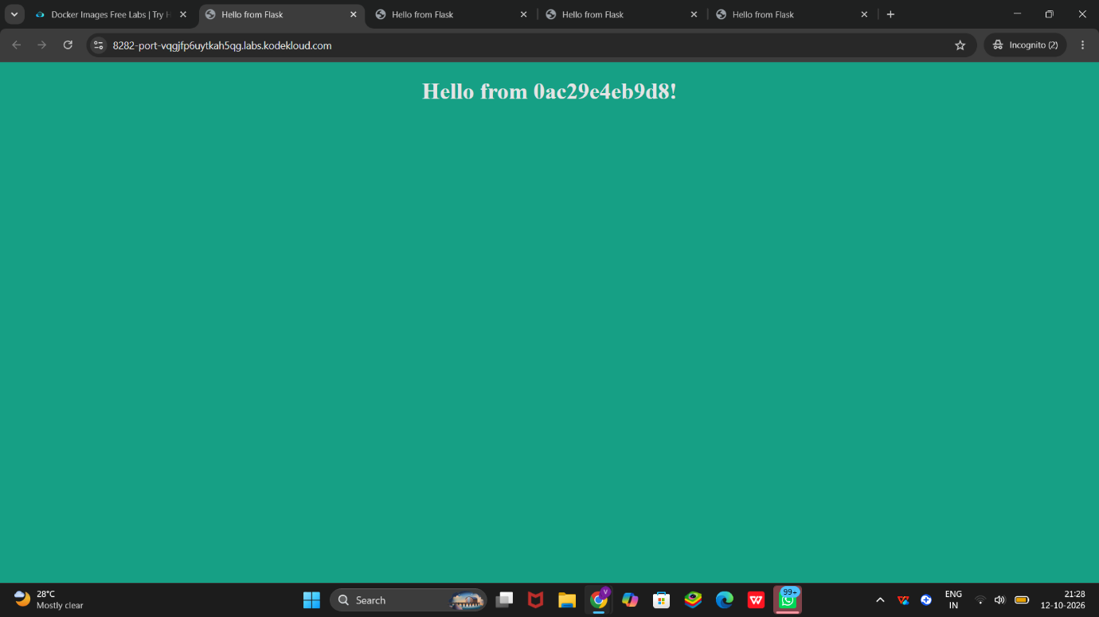
Step 8: Open the second website
Use the KodeKloud preview link for port 8383.
Your screenshot shows a different heading:
Hello from af0c13aefe5d!
This confirms that the second container is also serving the application.
Step 9: Verify the containers
Run:
docker ps
Confirm that both containers show an Up status and that the ports are mapped correctly.
For additional troubleshooting, use:
docker logs CONTAINER_NAME
Replace CONTAINER_NAME with the actual name shown by docker ps.
Step 10: Confirm successful completion
Your first screenshot already displays:
Challenge Completed
You have successfully completed the KodeKloud Docker Images challenge.
You do not need to repeat the lab if that completion message is still displayed.
Interview explanation
You can explain the project like this:
I completed a Docker Images lab using KodeKloud. I used docker images to list images and inspect the webapp-color image tags. I used docker ps and docker ps -a to verify container status. I ran two versions of the application with Docker port mapping, exposing container port 8080 through host ports 8282 and 8383. Finally, I opened both applications in the browser and verified that they were accessible.
Key commands to remember:
docker images
docker images webapp-color
docker ps
docker ps -a
docker logs CONTAINER_NAME
These commands demonstrate basic Docker image inspection, container management, port mapping, and application verification.

